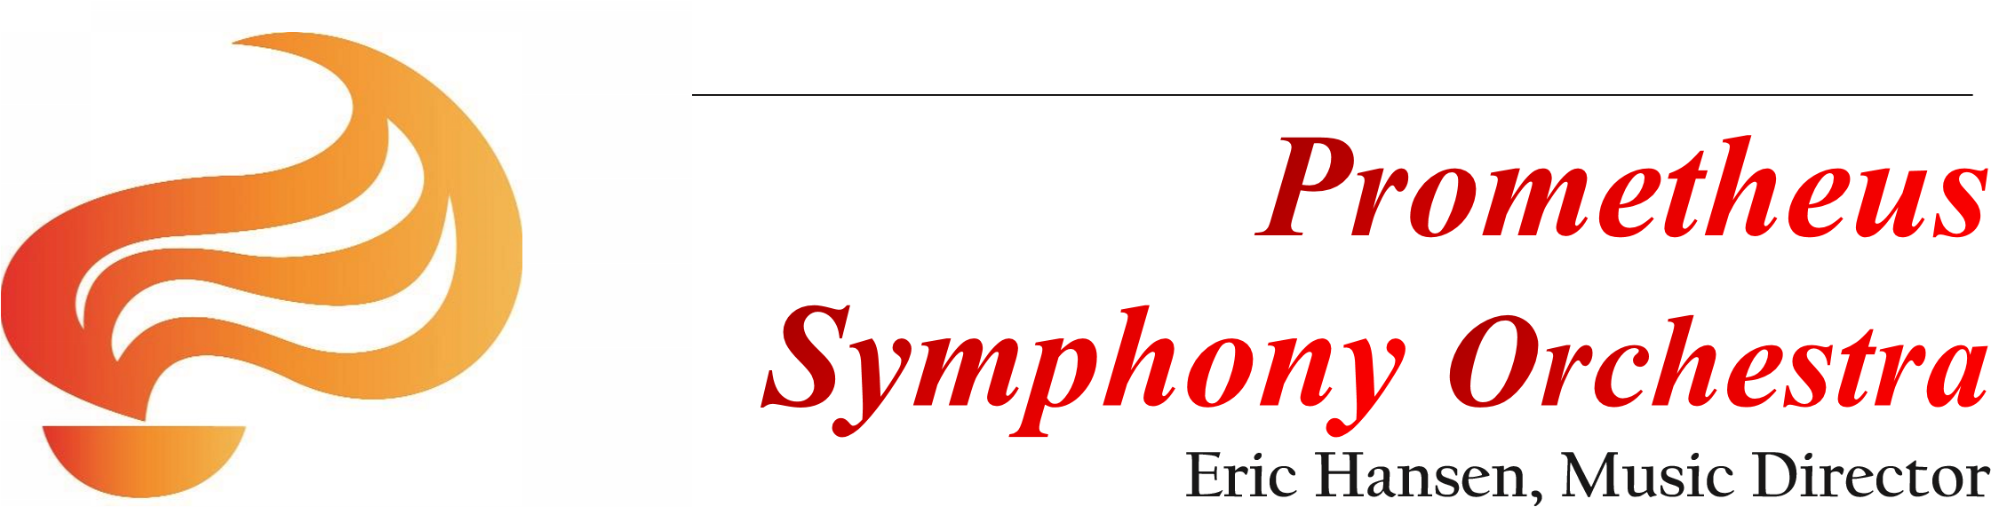
AUDITIONS

FELIX KHUNER YOUNG ARTIST
CONCERTO COMPETITION
Saturday, November 3, 2018
from 10 a.m. to 5 p.m.
in Albany at Church on the Corner, 1319 Solano Ave
Open to Bay Area string, woodwind, brass, harp and percussion players
18 years of age or younger
Application Deadline: October 19, 2018
download application, competition rules and information at
www.PrometheusSymphony.org -- Concerto Competition _{page}
or email: ConcertoCompetition@PrometheusSymphony.org
Winner will perform with the Prometheus on January 27, 2019
and receive a $200 award and a professional recording of the performance

